1. Open URL <https://www.pythonanywhere.com/>
2. Click on “Start running Python Online in less than a minute”

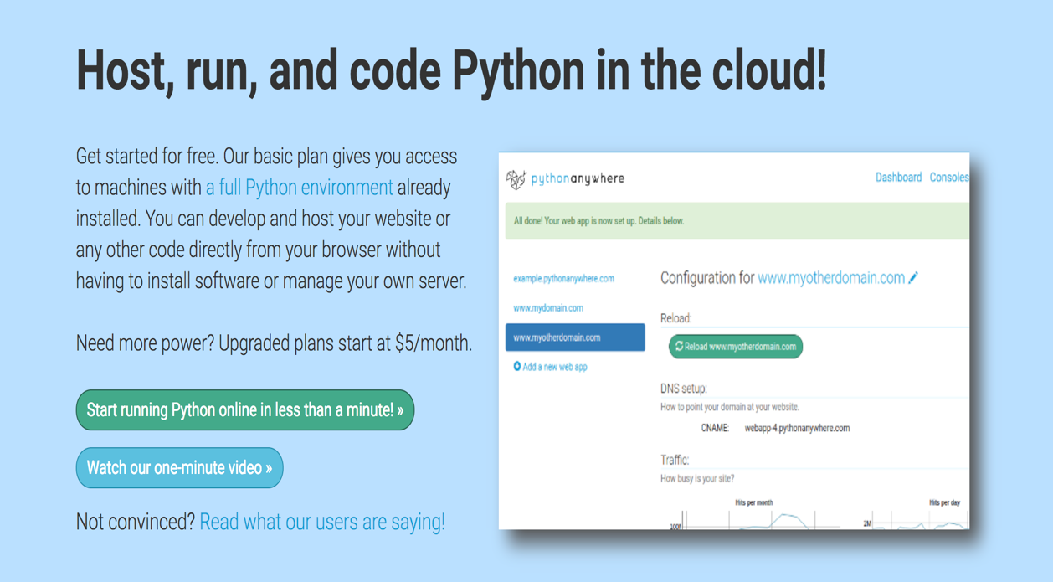

1. Click on Create a Beginner account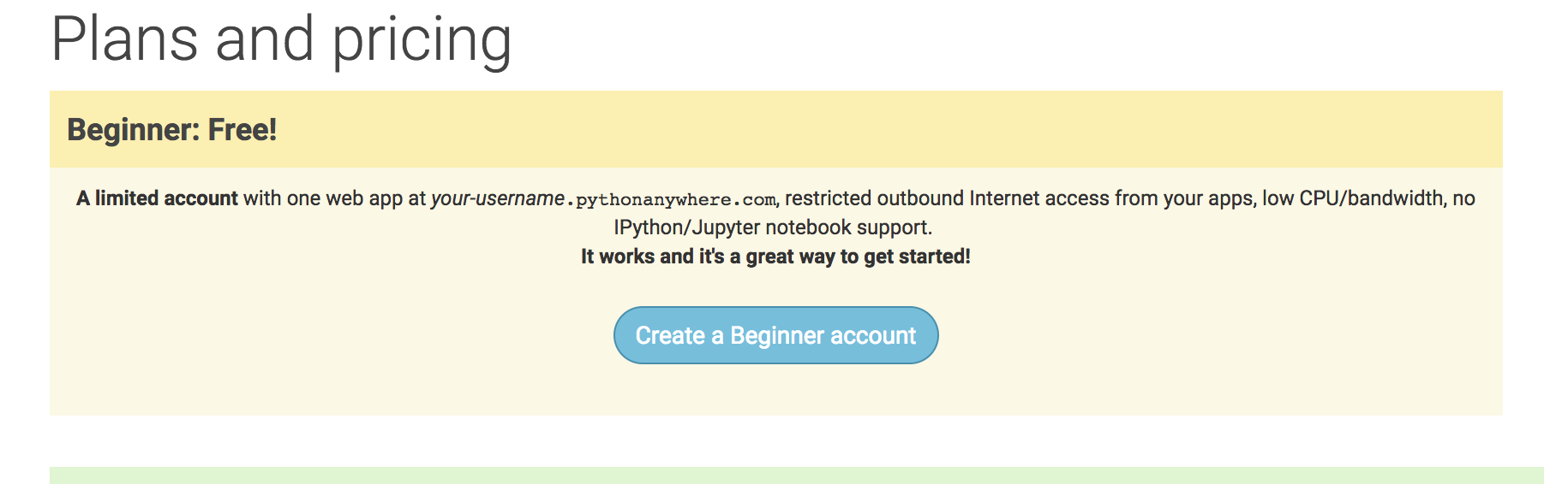
2. Register yourself

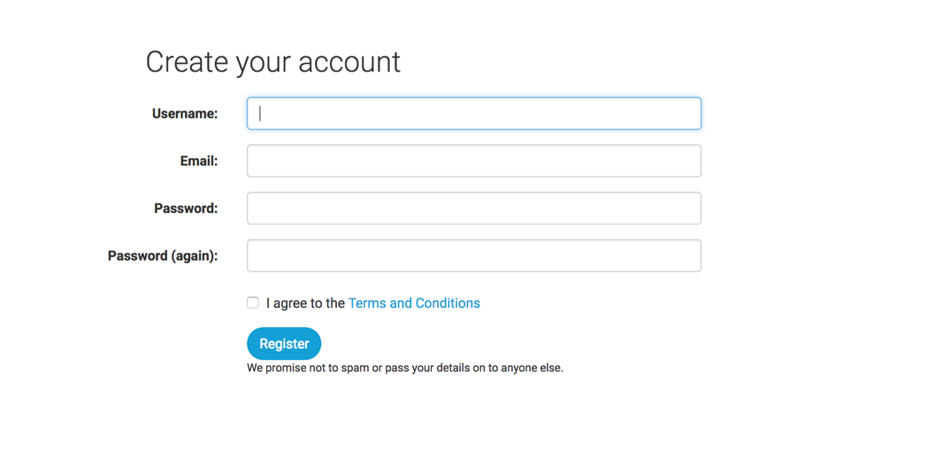

1. Click on End Tour

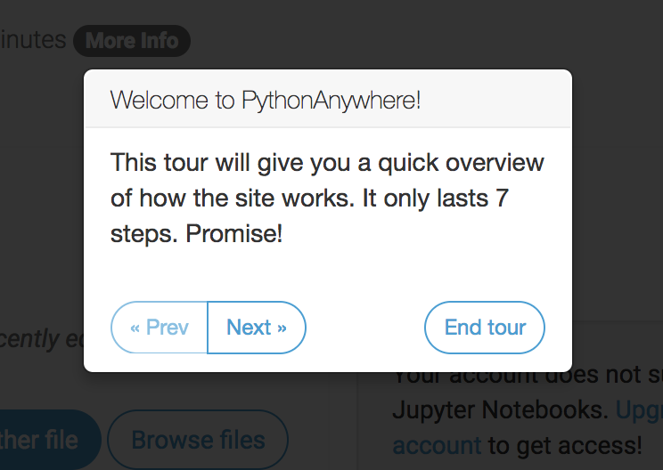

1. Click on Browse files

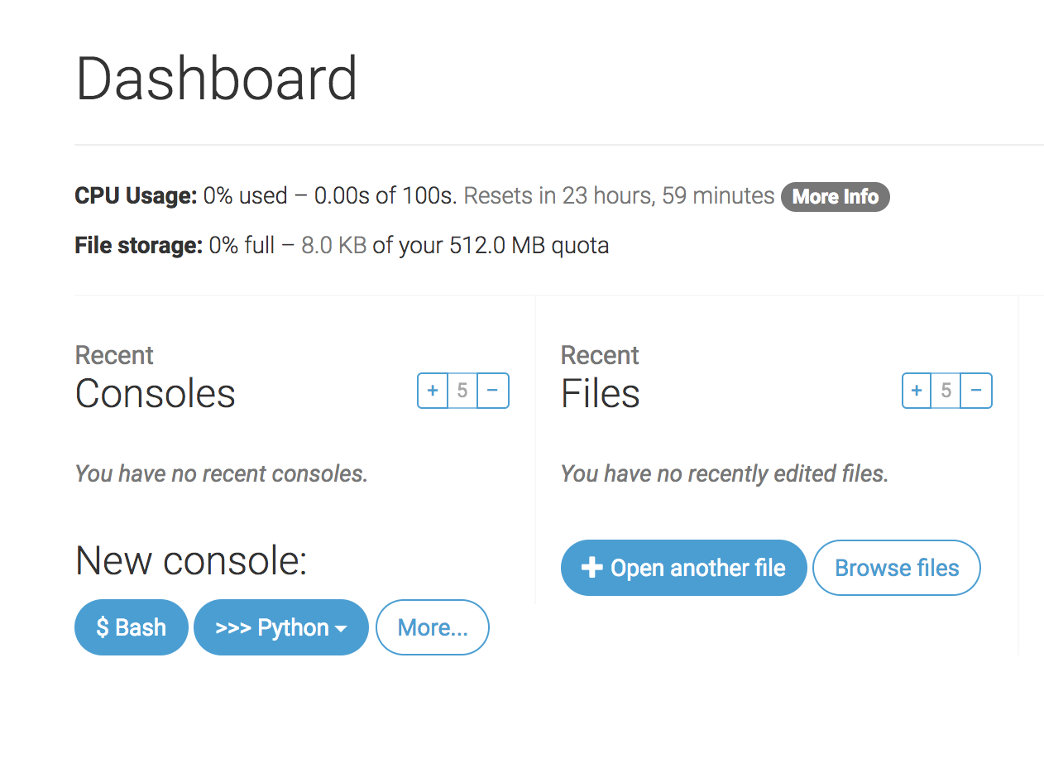

1. Click on Upload a file and upload your Python script and Data Files (if needed) one at a time. E.g., the script crawler.py does not need an input file. Similarly wordfrequency.py uses the output file from crawler.py. You may need to change the name of the input and/or output files inside the scripts.

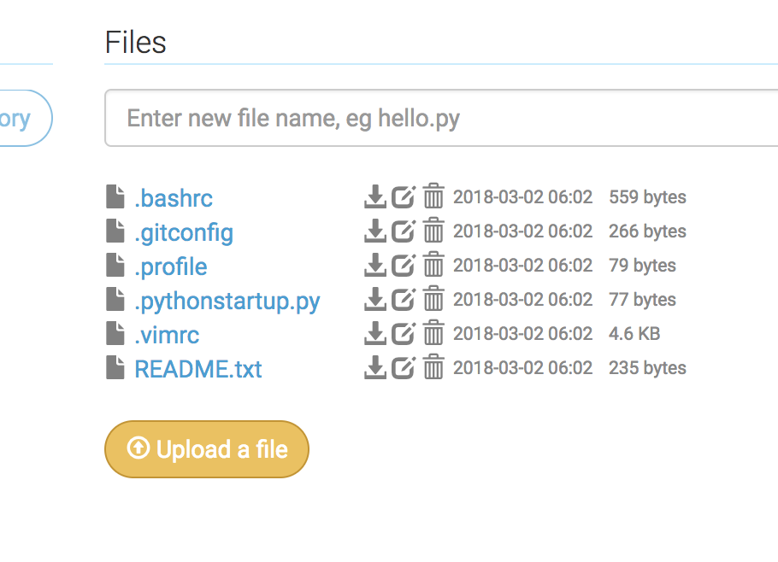

1. To run your code, click on the file name after you upload it (e.g., crawler.py) and then click on ‘Run this file’ (when you try to rerun again the Run button will appear on the top right)

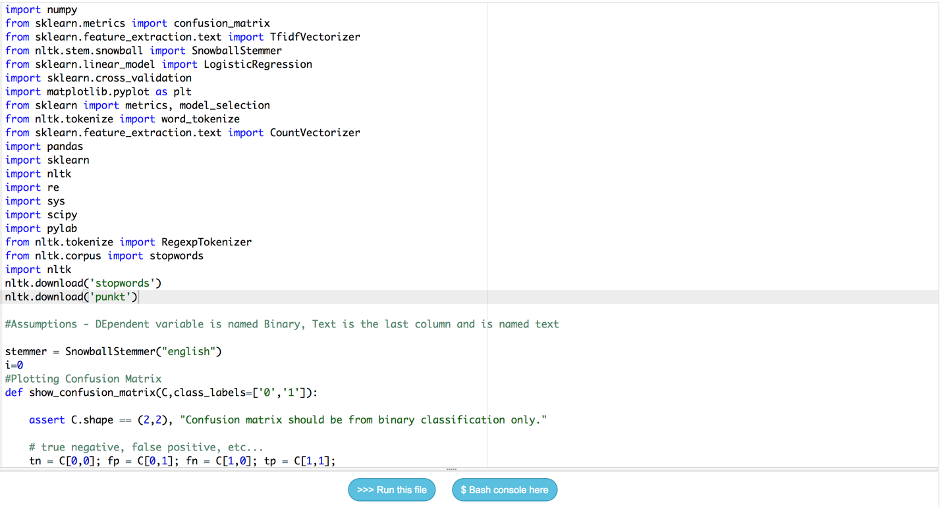

1. On the top right corner click on the three lines and select Files

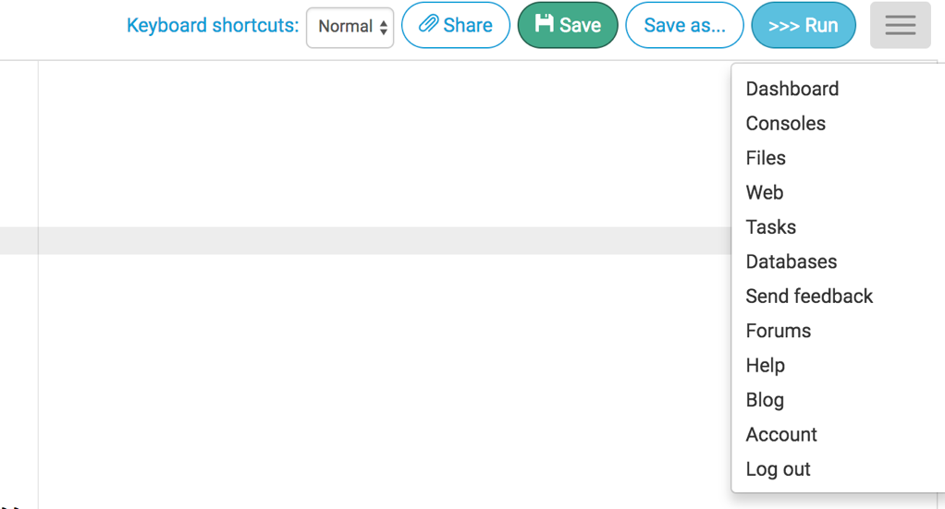

1. Your output files, if any, are saved here (Files Section)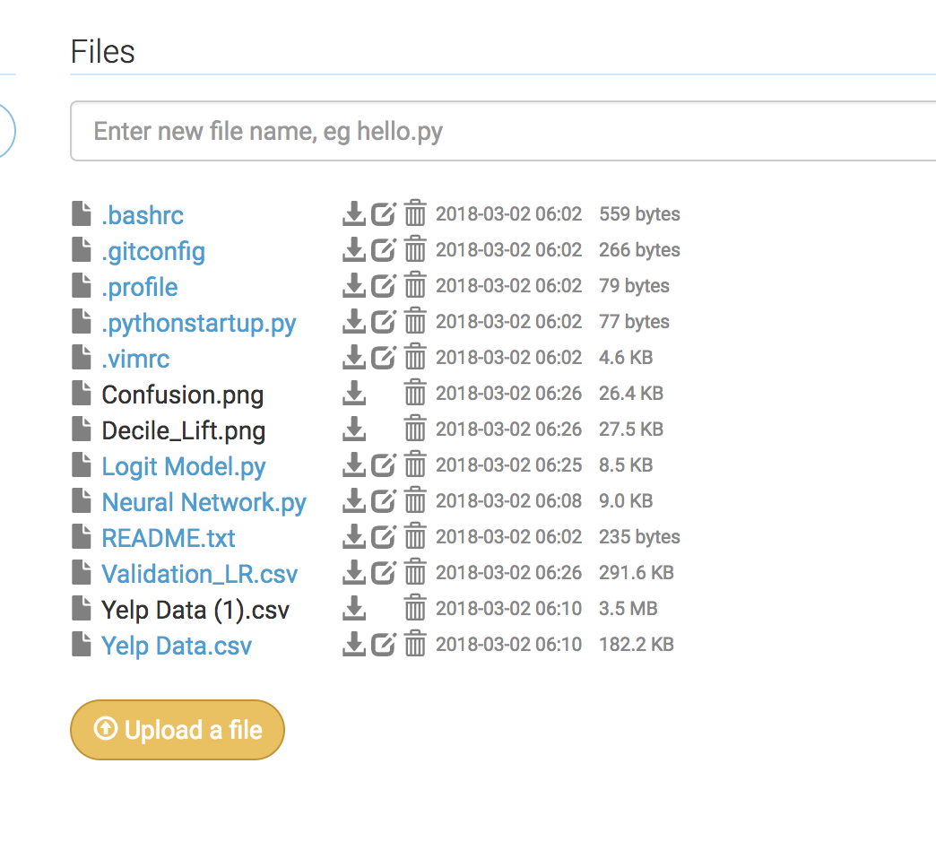

Extra Tips:

1. To save Memory:

The memory and space is limited. So, make sure you kill your processes once you are done using it. Click on Console

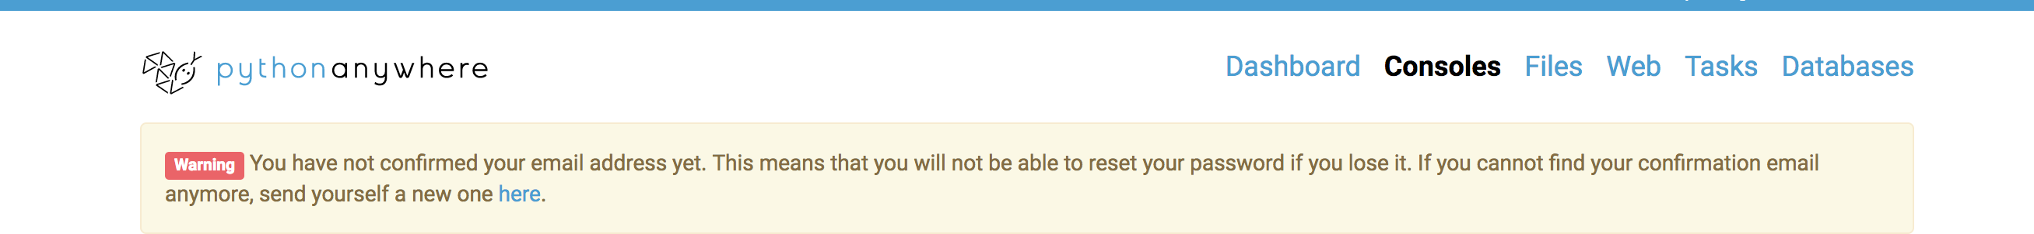

And the click on the cross mark to kill the process

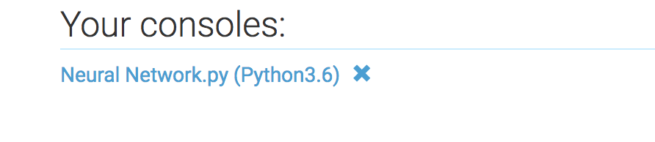

1. In case you get missing library error, click on Consoles

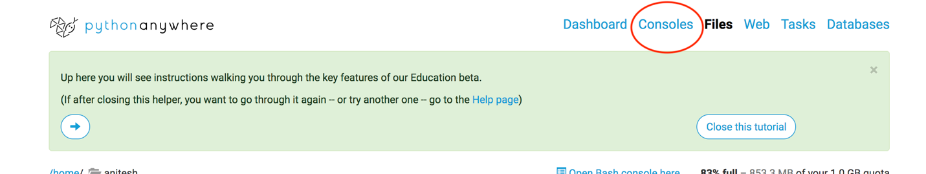

Under Start a new console section click on Bash, and type **pip install –user** followed by the name of the library.

E.g., **pip install –user selenium** to install selenium

